CLIMATE CHANGE ADAPTATION

A manual for trainers

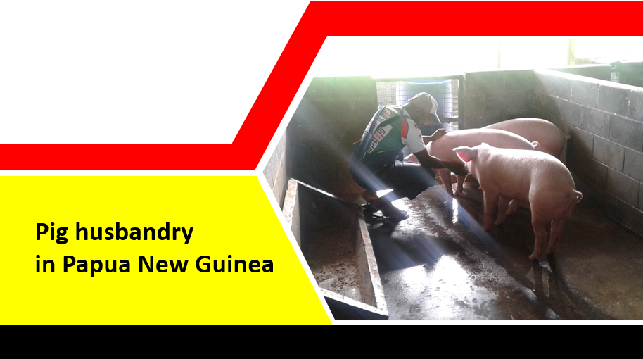

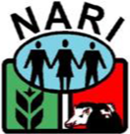

Supported by the European Union

Michael Dom,
Livestock Scientist,
NARI
European Union Climate Change Action Co-ordinator

Acknowledgements
NARI gratefully acknowledges the generous support of the people of the European Union in the Action - Strengthening food production capacity and the resilience to drought of vulnerable communities.
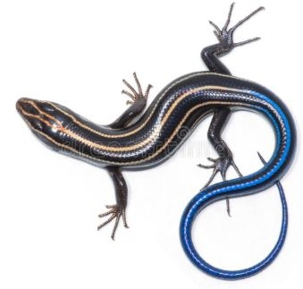

Table of Contents
Introduction 1
About this training 1
What’s in the training units? 1
Learning goals 1
Some information to prepare trainers 2
Session 1. Feeding: food, water, and related health issues 4
Learning Goals 4
Food and water for pigs 4
Feeding pigs 6
Growing, processing and storing feed for pigs 6
Watering pigs 9
Session 2: General welfare and care 11
Learning goals 11
Handling and restraining pigs 11
Housing for pigs 13
The needle teeth of young pigs 15
Castrating piglets 17
Identification: Ear notching 20
Session 3: Parasites and other common diseases of pigs 1
Learning goals 1
Internal parasites of pigs 1
External parasites cause skin infections 4
Session 4: Reproduction and growth 1
Learning goals 1
Heat (Oestrus) 1
Pregnancy and farrowing (Giving birth) 2
Care of the sow and piglet 4
Growing and finishing pigs 6

Introduction

About this training
This training will cover four basic areas of best practice in pig husbandry. It is not a complete course on the entire body of knowledge available about pig production. This training will not solve all our problems but it will help us to be in a better position to get to work on solving them.
The four sessions in this pig farming module will explore key areas for improving local smallholder pig farming practices which are equally applicable to large scale commercial piggery as they are to village piggery settings.
The overall aim of this training is to have better knowledge and skills to help make pig farming more successful and sustainable for smallholder farmers, particularly when faced with challenges such as drought events. The training allows farmers and rural workers to learn and share what they know about raising pigs and how to manage pig farming during good and bad seasons.
When delivering training to farmers this pig unit should take within one week to complete. Each training session provides basic guides, best practice examples and key talking points which are designed to get participants thinking, sharing and learning in groups.
In this way the training process also depends on their own combined experiences and knowledge to help them all draw a clear picture of how they want their pig farming to be economically successful and strengthened against the challenges (resilient) brought by climate change.
While some communities may have experience with keeping pigs over many generations both traditional and modern farming is challenged more than ever by growing population and developing industries, creating competition for land as well as food-feed crops, competition for limited fresh water resources, increasing demand for animal protein, emerging and endemic animal diseases and climate change induced drought or flooding. Despite all this we still keep pigs.
In fact, pigs are the most common livestock kept by smallholder farming communities all around the world. Pigs play an important role in the daily life, culture and livelihood of people in Pacific Island countries like Papua New Guinea.

What’s in the training units?
There are four sessions in this training module. Each session should preferably take one day and include a practical learning experience, field visit and a group experience sharing.

Learning goals

Farmers will
Learn about and share their knowledge on
- Feeding: food, water and related health issues
- General welfare and care
- Parasites and other common diseases of pigs
- Reproduction and growth
Below are some terms used in pig farming which may be unfamiliar. It is useful to write down what these terms mean as you understand them. That will also help when you need to think about translating the terms into Tok Pisin or a local language for farmers to understand. Some terms you may decide do not need to be used, but a trainer should know what they mean in case a trainee wants to know more.

Key words and concepts
- Ear notching
- Farrowing
- Fostering
- Hand rearing
- Handling
- Housing
- Oestrus (heat)
- Parasite
- Restraint
- Skin infections
- Teeth clipping
- Weaning
You may want to add to this list so you can be prepared to answer farmer queries too.

Some information to prepare trainers
There are additional learning resources available from NARI and other extension sources, and farmers also have their own store of knowledge. Try to make the best use of these different sources of knowledge and information. Think of the training as a ‘problem solving exercise’: involve everyone in the training because some may have problems for which others may have solutions.

Starting the course
- When starting your training program use the introductory notes provided in the training overview for ‘Getting to know each other”
- In the training modules, summary notes for each Session are brief and you can add to this from your own knowledge, using other information and notes provided (e.g. NARI Toktoks) and from farmer feedback during discussion
- Further advice and information will be available to everyone from NARI staff so give them our mobile numbers and email if they have an address

Thinking together
- Share your own experience and thoughts about pig farming with your farmers
- Encourage them to share their knowledge and also let them know that everyone has something important to say whether we agree with them or not
- Talk together to agree on how small training groups may be formed and make sure that all members feel welcome to participate even if they choose one or two people to lead their group

Working together
- Farmers learn best by watching and doing tasks (practice) rather than listening to stories (theory)
- Try to arrange practical sessions for observing the farming and piggery of a local volunteer, for example, is there is a pig which is ill then that becomes a good chance for seeing, talking about and trying take some actions to help the animal and its owner
- In class sessions, sketching maps (e.g. village walk-thru, hazards or resources maps), creating hand-drawn diagrams or picture presentations is a good way to get more participants playing a part in group work
- Don’t just sit and work, move around to group areas or do a fun exercise or game. In the field don’t let people to wander off, give them a task to do or an item to look for so that everyone can have a chance to report back.

Bring everyone together. Ask a leader to say a word of prayer. And then get started!

Session 1. Feeding: food, water, and related health issues
Pigs, like humans, are omnivores, animals that both eat plants and animal protein. This is also why pigs tend to compete with humans for foods, like the favourite sweet potato roots and cassava tubers, as well as grain crops like corn and wheat. The pig digestive system (the inside parts of the pig guts) works almost the same way as the human digestive system.
Pigs will eat some plant feeds, like sweet potato vines, kangkong vines and kikuyu grass, but this does not provide all the nutrition that a farmed animal needs in order to grow well or produce offspring.
Unlike sheep and goats, a pig’s digestive system cannot handle large amounts of roughage feed, like grass, vines and leaves, which are made up of a lot of fibre, which makes feed bulky but can also be a useful food nutrient. Pig farmers usually have to provide some more nutritious feed to their animals even if their pigs are allowed to forage.
Pigs must have the right amount of nutrients in their food in order to grow and stay healthy. Also, pigs need plenty of clean, fresh water every day.
Growing animal food, preparing and storing feed are major farming work for smallholder livestock farmers. This daily work can quickly become a challenge even during normal seasons, but during long dry seasons or drought, and even during long wet seasons, simple needs can become big challenges.
The best way to overcome farming challenges is to plan in advance what daily tasks and safety measures can be taken for securing animals (for selling or breeding) and providing for their feed and water needs.

Learning Goals

Farmers will
- Know the types of food pigs need to grow and stay healthy
- Understand better about feeding pigs
- Understand the need for iron injections
- Be able to make and mix their own basic pig feed

Food and water for pigs
Pigs are omnivores and will eat almost anything. If pigs are kept in a well fenced field, they will eat all the plants and grass nearby. After they finish the plant parts above ground, they will dig up all the roots and eat them too. The farmer can make use of this habit of pigs.
If pigs are put in a field, they will clear it, root it up and fertilize it (from pig droppings). But if the farmer does not want the pigs to dig, they can be fitted with a nose ring (a metal ring placed through both nostrils) or tethered (tied up). A pig with a nose ring cannot root up plants. A tethered pig is stopped from roaming anywhere else. But not all farmers use these methods and pigs will need to be trained!
The biggest problem with allowing pigs to roam freely is the danger that they will damage food gardens if they are not well controlled. In many communities this traditional practice of free-ranging pigs is still a concern. Talking about this problem is important.
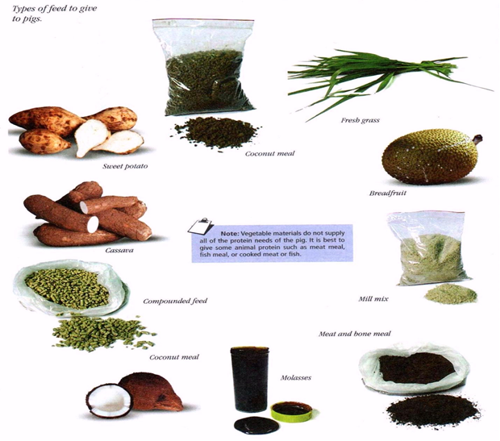

What a pig needs in its feed
Like other animals, pigs need carbohydrates, proteins, fats, minerals and vitamins in their feed. Pigs will grow faster if they are fed a balanced diet, combining different ingredients to give the right amount of nutrients. Mixing different kinds of food is the best way to ensure that pigs get a diet with the proper amount of nutrients.
The following are examples of foods that supply the nutrients needed by pigs.
- Starchy crops such as breadfruit, cassava and sweet potato are rich in carbohydrates, which are important source of energy. Meat meal, fish meal, coconut meal and palm kernel cake are protein rich foods.
- Coconuts, coconut meal, palm kernel cake and tallow are high in fats, which also provide energy.
- Fresh leaves, coloured fruits and vegetables are a good source of vitamins and minerals.
- Waste vegetables and household scraps can be given to pigs. Household scraps, especially those containing meat, must be boiled before they can be fed to pigs.
- Food stuff contains nutrients (protein, carbohydrates, minerals and vitamins) which animals use for growth, health and reproduction.
- Different types of foods provide different amounts of nutrients to pigs.

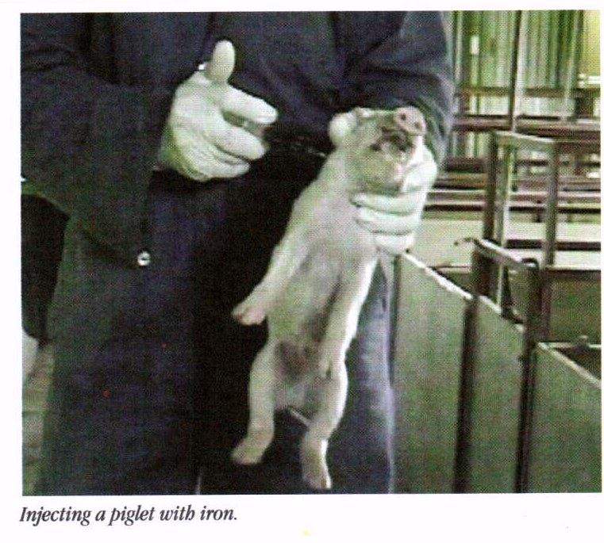
The need for iron injections – or provide clean soil and greens
Piglets raised outdoors get enough iron from eating soil. When pigs are raised indoors and do not have access to soil, the piglets may not get enough iron because the sow’s milk does not contain enough iron. This can cause a condition called piglet anaemia.
Piglets that do not get enough iron may become weak and die. To make sure that piglets receive enough iron, newly born piglets can be given an iron injection.
Other ways to provide the piglet with iron are to put soil (from an area where pigs are not kept) into the pigpen, and to make sure that piglets are given lots of green leafy vegetables to eat every day, example sweet potato leaves or mulberry leaves.

Feeding pigs
Pigs kept in a pigsty (house or pen) need to be given all their feed requirements every day. If pigs are given only enough to meet their daily feed requirements, they should be fed twice a day, one feed in the morning and one feed in the evening. If pigs are given more than enough to meet their daily feed requirements, they can be fed once a day.
- Pigs that are foraging for food in the field can be offered one meal a day of extra feed. They can also be given more feed, for example vegetable waste or swill, when it is available.
- The amount of feed a pig can eat will depend on its weight and the composition of the feed. Suggested feeding amounts are provide in Table 1.

Growing, processing and storing feed for pigs
Most smallholder pig farmers, whether in the village or near town areas, will usually grow some garden food for their pigs. Some farmers have food garden areas set aside just for growing pig feed.
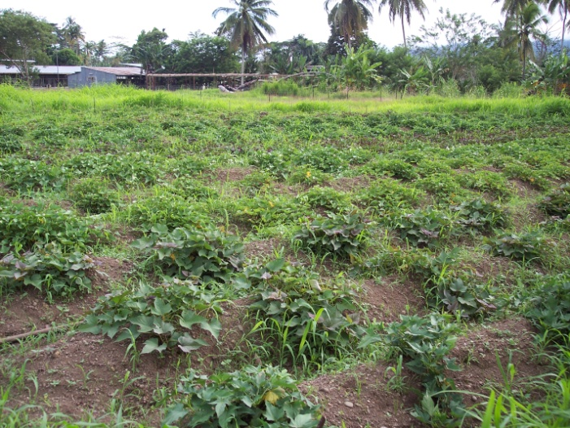
This type of self-sufficient farming is common and follows a long tradition in our country. The job is not going to get easier but we can make it work better if we work at it smarter.
The first step is to know how much feed pigs of different sizes need to eat in order to grow well and produce meat or more piglets. That way you can plan for the kind of pigs you want to keep and the number of pigs that you can take care of well – to make profits and not losses of time, effort and money!
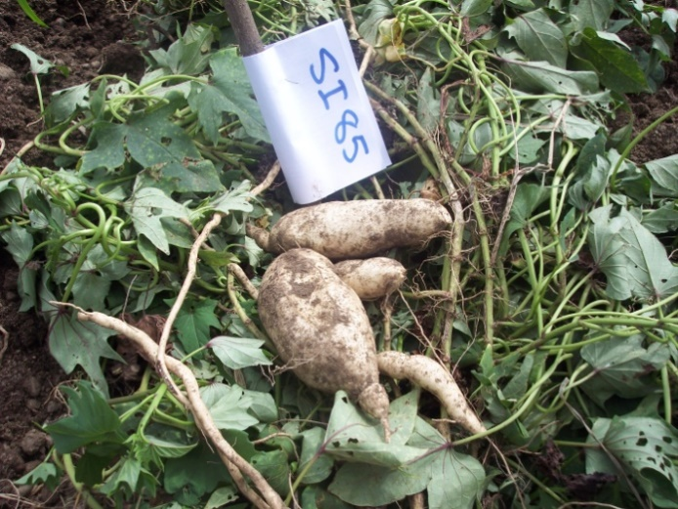
A pig farmer will also need to know how much weight food, like sweet potato and cassava, can be grown on their land. This means measuring the size of land and the weight of food that is harvested. Some estimates have been made by work at NARI and can be shared with farmers during training.
It is important to understand that pigs eat to satisfy their bellies with ‘dry matter’ feed, that means all the food nutrients without water. Water is very important in the pig’s body but it does not provide very much nutrition apart from some minerals.
Local pig farmers may need help working out how much feed they can get from the garden land they use.
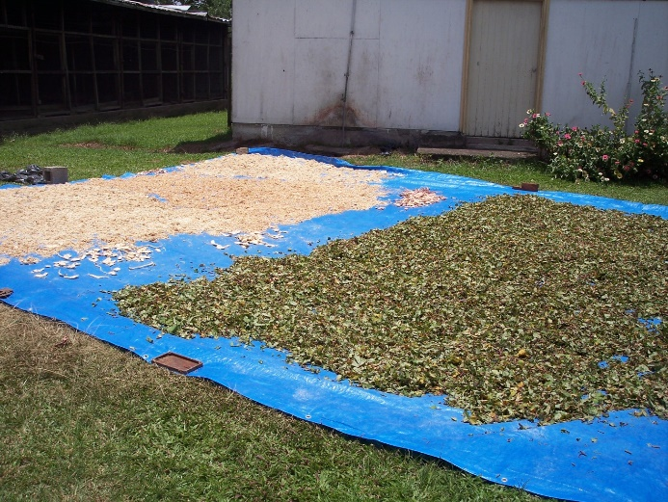
Table 1 shows the total dry weight of feed that different sizes of pigs need for good health, growth and providing offspring. But it does not show how much ‘fresh weight’ of common feed crops can be used. You will learn more about how to mix different foodstuffs to make feed in another of our training modules.
The second step is to know what kind of garden foods, forages and other feed, like wheat millrun, copra meal, fish meal or even stockfeed you are able to grow or buy.
Most farmers use sweet potato and cassava as pig feed. These root crops contain a lot of water and the amount of dry matter is not as much in feeds like wheat millrun or copra meal.
A good rule of thumb to use for sweet potato and cassava roots is: 3 kilograms of fresh weight is equal to 1 kilogram of dry matter feed.
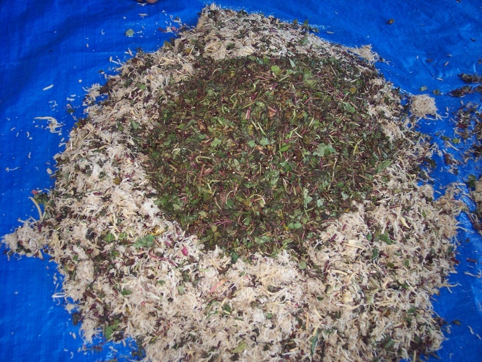
A young pig (less than 3 months old) may eat three kilograms of fresh sweet potato or cassava in one day. A bigger pig may eat six to eight kilograms in one day.
For sweet potato vines and cassava leaves (and most other greens) the rule of thumb is: 1 kilogram of greens is equal to only 100 grams of dry matter feed.
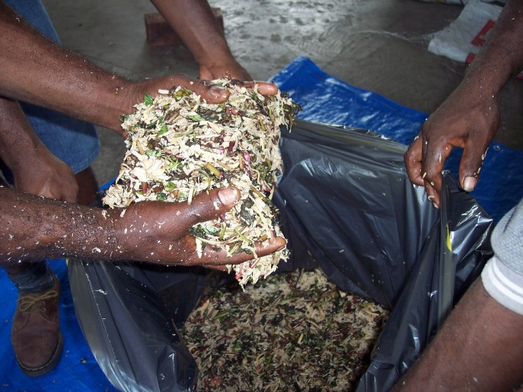
Young pigs won’t eat more than one kilogram of leaves. A bigger pigs and sows, especially when pregnant or nursing piglets, may eat more than one kilogram of greens. But bigger pigs and sows, should not be given more than 2 kilograms of greens a day because this may cause problems in the gut.
One way that more sweet potato and cassava roots as well as greens can be fed to animals is to dry them before feeding. This can be done by chopping up the foodstuff and placing on a sheet to dry by sunlight.
When the roots and greens material is well dried the feed can be placed into bags or bins and safely stored for a longer time.
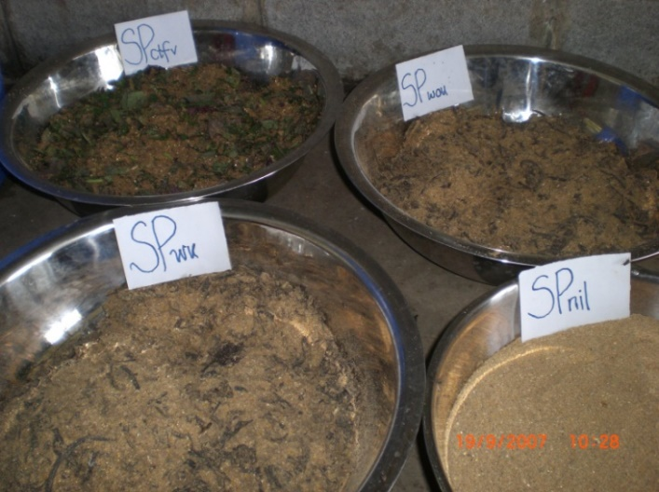
Processing and storage of dry feed is a good way for feeding animals well and for making better use of garden land by harvesting and then growing new crops or fallow on the same land.
Sweet potato, cassava and greens can also be stored in partly wet form, after chopping them up and packing them very well into air-tight bags or containers. This process is called ensiling.
Ensiling allows fresh feed material to ferment, like coffee pulp or cocoa pods, and change into a more stable form that allows it to be stored for much longer than dry feed even though it still has some water in it.
As part of this training we will also demonstrate how to carry out feed processing for storage as dry feed and as ensiled and fermented feed. You will also learn how to prepare and mix the best type of feed for your pigs using different feedstuff, like sweet potato, copra meal and fish meal.

Watering pigs
If pigs are unhappy with their feeding, they will start to lose their form.
Also, if pigs are sick, they will eat less and very quickly lose their form.
Always provide pigs with enough feed in a dish or in a clean area.
Always provide clean fresh water.
Pigs must always have access to fresh, clean water. Pigs will drink more water during hot weather. The water requirement for the best practice to keep healthy and well performing pigs are shown in Table 1.
One way many farmers provide water to their pigs is providing boiled feed with the watery soup. But pigs will still need some fresh water to finish eating well.
Boiled feed should be allowed to cool before offering. But boiling feed also means that water will need to be fetched or stored for animals.
Pigs enjoy wallowing in mud because they need to cool their bodies. On concrete pens provide a wet area. On wood floors make sure the underneath is upraised and clear of waste.
During normal seasons that may be easier or take some work but during long dry seasons or drought, providing water to pigs will be very challenging.

Table 1: Daily water and feed requirements for pigs
Stage of life (age) | Average size (kilograms) | Amount of water daily (litres) | Amount of feed daily (kilograms)
Young grower (1-2 months) | 15 - 20 | 3-5 | 0.5 – 1.5
Grower (3 months and more) | 25 - 60 | 5-12 | 1.5 – 2.5
Dry sows/Boars/Finished pigs (8 months or more) | 70 - 120 | 12-15 | 2.5 – 3.0
Pregnant sow | 100 - 120 | 12-20 | 2.5
Lactating sow | 80 - 100 | 20-30 | 5..0 – 6.0
Some strategies for providing water during good and bad seasons:
- Find a water drum or bin to store fresh water for using when other sources like rain-water are not available. But don’t let the water sit in the container for too long, use it and refill when there is enough water.
- Feed more forages to bigger pigs and very wet feed like chopped banana suckers and cooked taro leaves (drain the boiled water first), kru sako pods, cooked pumpkin with water and avocados.
- Ensiled and fermented feed contains some water and also lowers a pig’s need for plenty of water.
- Provide a mud pool for pigs to cool off so that they do not get too hot – but make sure there is not too much dirty water or they will drink it too!

Food and water for pigs
- Feeding pigs properly needs good planning of food gardens, knowing the expected harvest and growing, gathering or buying different feedstuff.
- Feed and water storage are the best means of providing for animals during long dry seasons or drought.
- It may be necessary during bad seasons to provide less feed to bigger animals, while some stock may need to be sold or killed for food.

Thinking together
- In groups get your trainees to first think and then discuss about their own pig feeding, different food they offer their pigs, what are the most abundant, most preferred, best for growth or health, and how they provide fresh water to their pigs
- Do some of them have experience with semi-commercial piggery or profitable village piggery projects?
- What do they think about local feeds and commercial feeds?
- What are some problems or challenges they face with feeding pigs during droughts or long wet seasons and how do they overcome them?

Working together
- Make a combined table list of these foods and their benefits to pigs or for the farmers own resources
- In groups ask your trainees which of the three questions above they choose to discuss more about and make a group presentation about their thoughts
- It’s important to capture the group responses to these questions so that we can better understand the problems, ask better questions by knowing the causes and effects and possibly find solutions together
- Get them to use, along with you, visual tools like tables, charts, diagrams or pictures with story-telling to capture their responses

Session 2: General welfare and care
There are some simple steps which are important for keeping pigs in good condition. Session 2 is about handling and restraining pigs, housing for pigs, clipping the needle teeth of young pigs, castrating piglets and, in bigger piggeries or breeding herds, identification by ear notching or tagging.

Learning goals

Farmers will
- Safely handle young and old pigs and restrain pigs;
- Explain how to keep pigs in a field;
- Describe types of housing (buildings and pens) for pigs and why pigs must be housed properly;
- Describe proper housing for piglets;
- Describe the proper method for handling the sow and her young;
- Explain why male pigs are castrated and when castration is done;
- Describe how to restrain pigs for castration and how to castrate them;
- Explain why it is a good idea to be able to identify animals.

Handling and restraining pigs
Pigs can be dangerous, but if you use the proper techniques they can be easily and safely handled.
In most cases it is only necessary to restrain pigs when they need to be examined closely for an injury or illness, when more care or medicine needs to be applied.
Usually a pig may be tricked by offering them a little feed so that a noose can be easily fit around its nose. Once the nose is secured the pig can be made to move to where they can be restrained firmly.
Close body contact is necessary so you don’t have to pull or push too much with your arms. Be firm but gentle. Animals can sense your confidence when you handle them.
It is not advisable to try to handle wild, feral or bad-tempered animals unless you really know what you’re doing. Remember sows can be just as dangerous as boars, and even ore when they have piglets.
Most often it is easier to use barriers, like a small wooden gate, to move pigs from one pen to another.
Younger pigs are easier to handle – but with care!
It is good practice for farmers to become familiar to younger animals on a daily basis, and especially with a breeding sow. This builds the pigs experience with being near to and handled by humans, and makes handling and caring for them a lot easier.

Restraining a pig
- When a pig needs to be treated or examined, it must be restrained.
- Restrain a pig by holding it with ropes against a wall or fence.
- Restrain large pigs by placing a rope or wire loop (a pig snare) around the snout.
- Animals respond well to good care and good care makes a piggery work better!
- The more familiar you are with your animals the quicker you will find out if something is wrong with them – animals talk with their bodies and actions.

Thinking together
- Ask your farmers how they handle their pigs and how confident or satisfied they are with how they do things
- Do they think there are some way they can improve how they handle their pigs?
- What steps will they take to become more familiar with their pigs?

Working together
- It would be best to arrange this part of the training as a practical demonstration. In a training exercise, it is best to work in a piggery where the farmer(s) are very familiar to their animals. This makes the animals more comfortable with being approached, so workers can apply the practice without too much fuss, getting injured themselves or hurting the pig.

Handling the young pig
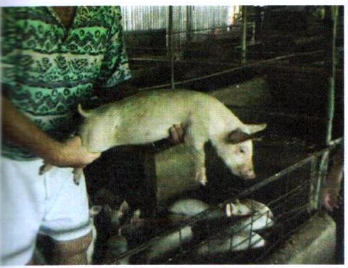
Young pigs (piglets) can be picked up by hand. To lift piglets safely:
- Catch the piglet from behind, and hold it by grasping the hind leg just above the hock. The hock is the ankle joint (see picture at left).
- Place your other hand under the chest and pick up the piglet.
- Support the piglet’s weight against you when you are holding it.

Handling the older pig
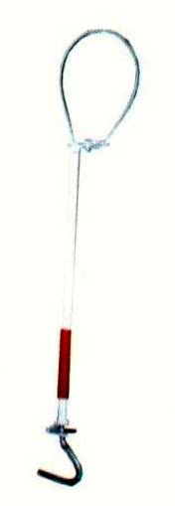
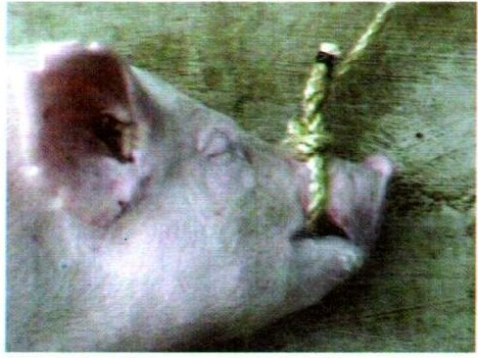
By the time a piglet is weaned, it is too heavy to lift. Once a pig becomes too big to pick up, it must be herded from place to place. It can be difficult to herd a pig. Pigs will naturally head for a gap (or opening) when you approach them or try to catch them. For example, if several people try to drive a pig, it will turn and try to charge between them. However, this habit of rushing for a gap or opening can be used to make the pig go anywhere the handler wants it to go.
Pig snare

Housing for pigs
Pigs can be kept in a field where there is a shelter, or they can be kept in a pigsty. Very important, pigs should not be allowed to wander around free. What they eat and where they go must be controlled. Otherwise, they can spread diseases including diseases that could affect humans.

Keeping pigs in a field
Wild pigs’ shelter in bushes and the roots of trees. Pigs do better if they are given a suitable shelter to lie and sleep in, like they would do in the wild:
Pigs can be kept in a field where they can feed on grasses and plants. The field must be surrounded by a strong fence or a wall. Pigs will push their way out of a field if the fence is not strong enough.
Pigs in a field should be given shelters to sleep in. These shelters are called pig arks or kennels. They can be made of wood or metal sheets.
Pigs should have access to shade so they do not get sunburned.

Housing and pens for pigs
Pigs can also be kept in a pigsty, either alone or in small groups.
- Choose an area that is never flooded in the rainy season.
- Do not build the pigsty near houses because smells and flies can become a nuisance.
- The pigsty should be a pen with a concrete or solid floor and a low shelter.
- Make the concrete floor slope away from the pig’s sleeping area. This allows the urine to flow away.
- Lay the floor on a good foundation that is 5-6 cm thick. If the concrete is too thin and cracks, the pigs will soon start to dig it up.
- Do not use an earthen floor. It cannot be kept clean and will lead to problems with parasites and other diseases. The pigs will dig the floor up.
- The walls of the pigsty need to be fairly smooth so that they can be kept clean. Germs can grow in dirt that gets into cracks in the walls.
- Make sure there is plenty of bedding in the shelter.
- Remove the dung every day. Pigs always drop dung away from their sleeping and feeding areas. This makes it easy to collect the dung. The dung can be then be composted, used in a digestor to make gas for cooking, or deposited in fish ponds
- Avoid washing wastes into lagoons or other waterways, where possible.

Housing for piglets
Breeding sows and their litters can be kept in pigsties or in open fields enclosed by a strong fence or wall. There must be plenty of bedding to help keep the piglets warm and it must be changed frequently.
If a litter is raised in the field, the shelter should be moved to a new place for the next litter. This reduces the risk of disease and parasitic infections.
If a litter is raised in a pigsty, the pigsty should be thoroughly cleaned with disinfectant and scrubbed out after the litter has been weaned and moved away. Proper housing for piglets reduces the possibility of health problems.
No matter which housing method is used, piglets must have access to a warm area that the sow cannot reach. This is called a creep. Put a temporary wall of boards or strong rails across part of the shelter. The bottom of the wall should be about 30cm from the ground to allow the small piglets to pass under it.
Piglets can be given feed in the creep. They can lie down there without the risk of the mother lying on top of them. If the weather is cold an electric light or a kerosene lantern can be put in the creep area to keep the piglets warm.

Housing for pigs
- Piglets are the future stock that will earn income and provide security.

Thinking together
- How well do local farmers take care of their piglets?
- Do farmers find it challenging to house piglets well?

Working together
- Talk about some practical ways that pig housing can be improved and if there is a way that good advice or assistance that can be provided to local farmers.

The needle teeth of young pigs
The piglet is born with eight teeth, four of which are called needle teeth. These needle teeth must be clopped as soon as possible after birth. Removing the needle teeth prevents the young pigs from biting the sow while sucking. It also prevents them from injuring one another while fighting or playing.

Why the needle teeth of piglets are clipped
The simple practice of clipping the needle teeth as soon as possible after birth prevents the following problems:
- Piglets bite the sow in their fight to get hold of one of her teats and suckle.
- The pain caused by this disturbs the sow, causing her to get up, which prevents her young from feeding.
- Injuries to the sow’s mammary glands can become infected, causing mastitis.
- In their fight to grasp the teat and suckle, piglets will bite and injure one another.

The best time to clip the needle teeth
The piglet’s needle teeth should be cut as soon as possible after its birth. This could be done when the pig is only 15 minutes old. Carry out the clipping quickly because the sow and her young should not be separated any longer than necessary. To clip the needle teeth, you will need:
- A pair of tooth clippers or side-cutters;
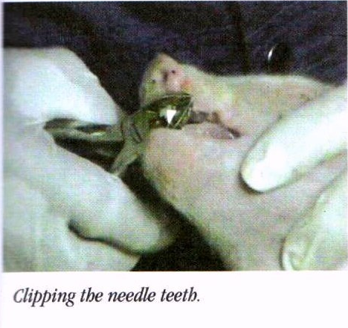
- Someone to help you separate the sow and her young;
- A box that contains bedding, and
- A clean, empty pen.

Clipping the needle teeth
- If the sow is not tied up, separate her from her young and place her in another pen. Take care because a sow with a litter can be dangerous.
- Clean the tooth clippers with soap and water. Wipe the blades with an antiseptic such as iodine, surgical spirits or Dettol.
- Corner the piglets and keep them together or place them in a box.
- Keep the young piglets warm.
- Hold a piglet’s head, and press the corner of its jaw so that the mouth opens.
- Place the clippers on either side of one pair of needle teeth, making sure that the tongue is not in the way. Tilt the head so that the pieces of tooth will fall out of the mouth.
- Cut the teeth as close as possible to the gum.
- Clean the clippers with antiseptic before using them on another piglet.
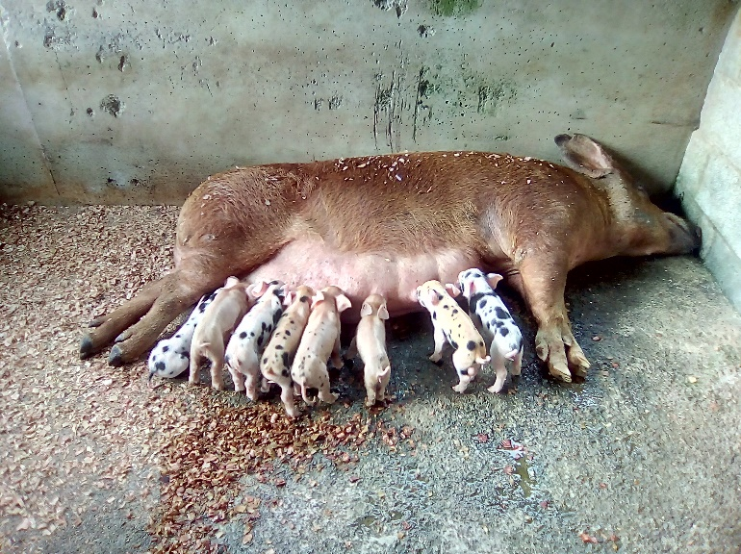
- When you finish, put the piglets back with their mother immediately.
Piglets must start milking a few hours after birth. This is critical for good health and growth.
This means from birth and over the first four to seven weeks the piglets will get the full benefit of the sow milk.
Clipping teeth is the best way to keep the sow happy with feeding piglets as long as needed.
Happy sow, happy piglets!

The needle teeth of young pigs
- When the teats on the udder become sore, they can also become infected and result in mastitis.
- Mastitis needs to be treated by a vet, and when it occurs it will stop the sow from producing

Thinking together
- Do farmers practice clipping milk teeth?
- Is mastitis a problem seen by local farmers?

Working together
- Discuss practical steps to help farmers, or even your district pig breeders, with this basic husbandry practice.

Castrating piglets
Castration, the removal of the testacies, is done on a male that is not needed for breeding. Castrated pigs are quieter and easier to handle. They become fatter than boars (male pigs used for breeding), and they produce meat that does not have a strong smell (boar taint).

Timing for castration?
- The best time to castrate young pigs is when they are 2-3 weeks of age. There are a number of ways to castrate pigs. The method described here is called the open method.
- It is not advisable to castrate larger pigs and boars unless there is strong reason.
- If boars must be castrated then make sure there is medicine and a vet or skilled and experienced stockman to carry out the task. The pig will need to be restrained and anaesthetics used.

Why pigs are castrated
There are good reasons why pigs are castrated:
- Most farmers want to control the mating that occurs when pigs are kept in groups.
- Boars often fight, causing injury to one another. Castrated pigs are quieter and easier to handle.
- A castrated pig will put on more fat and the meat of bigger or older pigs will not have a strong unpleasant smell (boar taint).

Open method
- You will need a very sharp, clean knife, razor blade or scalpel. It is best to use a new scalpel blade because these are sterile and very sharp. You also need someone to hold the pig.
- You will have to remove the sow from the litter. If possible, put her where she cannot see or hear the piglet.
- Remove your watch and any jewellery. Germs under rings and watches could get into the castration wounds and cause them to become infected.
- Wash your hands well with soap and water. Make sure your fingernails are cut short and are thoroughly clean, because germs under your fingernails can cause infections.
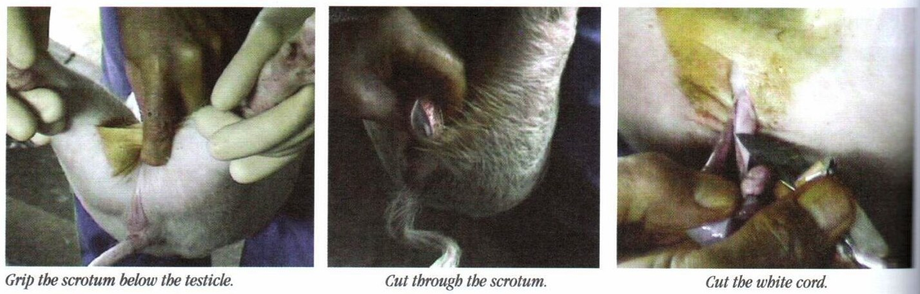
- Ask your helper to hold the pig by the hind legs and keep its head down while it is being castrated. Its body should be firmly held between the handler’s knees.
- Clean the scrotum with warm water and soap.
- Wipe the scrotum with an antiseptic such as iodine.

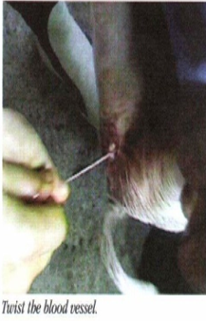
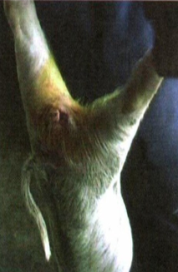
- Move the testicle into the scrotum with your finger. Then, using your thumb and index finger, firmly grip the scrotum below the testicle.Make a 2-3cm cut in the bottom of the scrotum. The testicle should pop out of the scrotum. Do not put your fingers inside the scrotum.
- Pull the testicle out of the scrotum and cut through the white cord. Leave the red blood vessel uncut.
- Pull the testicle out slightly further and twist it around several times.
- In young pigs, pull the entire testicle out to break the blood vessels.
- In older pigs, do not pull the blood vessel. Cut the twisted blood vessel by scraping up and down with the knife. This helps to reduce bleeding.
- Remove the second testicle in the same way.
- Apply a tincture of iodine, gentian violet, antibiotic powder or sulpha powder to the castration wounds.

Caring for piglets after castration
It is very important to take proper care of castrated piglets:
- Put the piglets and their mother on clean bedding.
- Watch piglets for signs of infection in the wound for the next week. If a piglet does not want to walk or is lame, this may be because of swelling in an infected castration wound.
- If a piglet develops an infection in the castration cut, treat it as you would on other wounds

Castration should be done in a clean area to avoid infection, and the piglets placed in a clean area afterwards.
If the castration is not done well or the cut is dirtied and becomes infected, the piglet will most likely need penicillin and a vet to clean out the infected area.

Thinking together
- Ask your farmers how they handle their pigs and how confident or satisfied they are with how they do things
- Do they think there are some way they can improve how they handle their pigs?
- What steps will they take to become more familiar with their pigs?

Working together
- It would be best to arrange this part of the training as a practical demonstration. In a training exercise, it is best to work in a piggery where the farmer(s) are very familiar to their animals. This makes the animals more comfortable with being approached, so workers can apply the practice without too much fuss, getting injured themselves or hurting the pig.

Identification: Ear notching
If there are only a few pigs, identifying them is no problem. Pigs can be identified by sight and the farmer may have given them names. In situations where there are a large number of animals, it is necessary to have some permanent way to identify them, especially if records are going to be kept. Being able to identify individual pigs makes it possible to compare pigs and select the ones that should be kept for breeding.

Methods of identification
There are several methods that can be used to identify animals:
- Numbered collars
- Tattoos
- Plastic tags on the ear
- Notching the ear

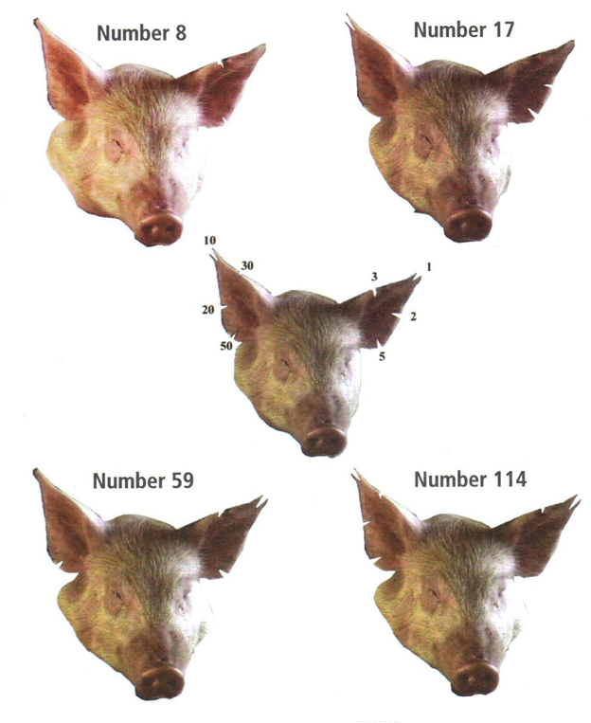
Notching the ear
Notching the ear is the easiest and cheapest way to mark a pig. Notching is easy to do and costs nothing. You can identify up to 121 pigs in this way. The method can also be used to identify other animals, for example, sheep and goats.
Use a pair of clean scissors or special ear notching equipment to cut a V-shaped notch out of the edge of the ear. Make the notch a few centimeters deep so it can be read from a distance.
The picture at left shows where notches can be placed so that they identify the pig by number. Notches on the left ear are for the numbers 1-9, and notches on the right ear are for the 10s.

Identifying pigs
- Knowing which pigs is which and who it belongs to is the most important reason – for breeding and security!

Thinking together
- What local practices are there for identifying pigs? Are they good enough or should they be improved?

Working together
- Talk in your group about identifying pigs for breeding and security.

Session 3: Parasites and other common diseases of pigs
Pigs can suffer from internal and external parasites. Some of these parasitic infections can be passed n to other animals and humans, so pigs must be cared for properly. Part 3 looks at the parasites that affect pigs and what can be done to safeguard the pigs in your community.

Learning goals

Farmers will
- Describe the problems caused by internal parasites;
- Explain how to treat and control internal parasite infection
- Describe problems that can be caused in humans by pig parasites;
- Recognize when a pig has a mange or lice infection;
- Explain how to control and treat mange and lice infections;
- Explain how to control and treat tick infections;
- Describe erysipelas (diamond skin disease) and how to treat it; and
- Describe the internal and external parasites that affect pigs.

Internal parasites of pigs
Pigs can be infected with internal parasites; that is, parasites that live inside the animal. The most serious infections are caused by roundworms. Roundworms cause poor weight gain in adults. In young pigs, roundworms can cause diarrhoea, weight loss, lung problems and death. Some roundworms can be passed from pigs to humans.
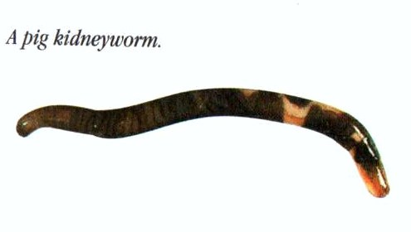
Roundworms

Update pending

Ascarids

Update pending

Stomach worm

Update pending

Roundworm infections
Pigs can be infected with many different types of roundworms. If the pig is infected by the large pig roundworm, you will see large roundworms in the animal’s dung. They are 25-40cm long. Another type of roundworm, which is common in the Pacific region, is the kidneyworm. The young kidneyworms live in the liver and lungs before moving into the kidney. Pigs can also be infected with pig lungworm, a type of pig roundworm that is carried by earthworms.

Some effects of roundworm infection are:
- Worms migrating through the liver of young and adult pigs cause white spots (milk spot) to develop in the liver. A liver with milk spot should not be eaten by humans.
- Worms in pigs 2-5 months old cause diarrhoea, weight loss and lung problems.
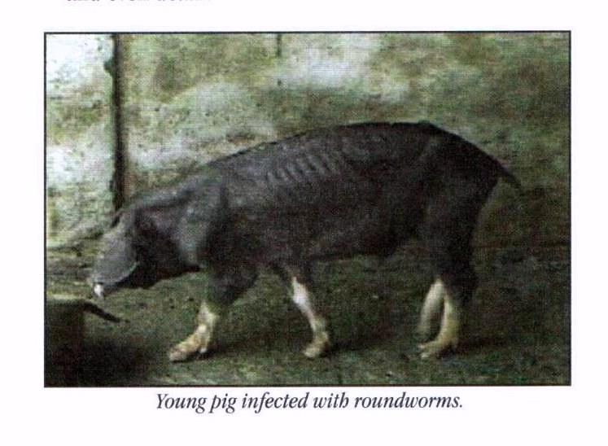
- Damage to the lungs caused by worms’ causes coughing, lung infections and even death.
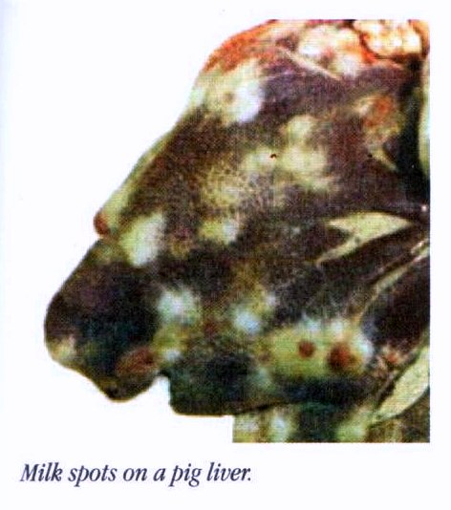

Treatment and control of internal parasites
- If the signs of roundworm infection are seen, the pig must be treated immediately, or the infection will spread quickly:
- Treat infected pigs with an anthelmintic medicine such as piperazine
- Treat the pregnant sow with a suitable anthelmintic a week before farrowing, so she does not pass the infection on her litter.
- One female worm may produce a million eggs a day, which pass out in the dung. These eggs can infect new hosts: for example, the piglets. The eggs can stay alive in the ground or the pigsty for up to 5 years. They will be able to grow into adult worms if they are eaten by a new host during that time. To prevent the worms from reinfecting the treated pigs or spreading to other pigs:
- Clean out the pens and shelters. Treat the walls and floor with a disinfectant. Leave the disinfectant on the walls and floors for 2-3 days before washing it off.
- If infected pigs have been kept out in a field, the land should either be ploughed and used for crops, or used as pasture for other animals. (Other farm animals are not infected by the types of roundworms that infect pigs).

Pig parasites that infect humans
Some pig parasites also infect other animals: for example, the trichinella roundworm. The adult trichinella worms live in the pig’s intestine, while young worms are found in the pig’s muscles (meat). Any animal that eats infected pig meat can be infected with the worm.
Trichinella

Update pending

Trichinella worms do not appear to be a problem for the pig, but in humans they can cause fever, pains in the joints and sometimes death. If humans eat undercooked meat from an infected pig, they can become infected. Thoroughly cooking pig meat will kill the worm and prevent the parasite from infecting humans.
Pigs can be infected with trichinella by eating rats that are infected with the worms or by eating other meat contaminated with worms. It is therefore important to thoroughly cook all meat before it is fed to pigs.
Another parasite that can infect both pigs and humans is the tapeworm. If a pig is left to wander around, it may eat plants contaminated with human faeces that are infected with tapeworms. In this way, the pig meat can become infected with a tapeworm from humans. If the meat of an infected pig is not properly cooked, people who eat is can become infected with the pork tapeworm. Infected humans may suffer from stomach problems such as diarrhoea, constipation or stomach pains.
Tape worm

Update pending

Preventing infection and the spread of parasites
To control internal parasites:
- Do not allow pigs to wander around free.
- Keep pigsties, pigpens and shelters clean and dry.
- Always make sure pork is thoroughly cooked before eating it.
- Always thoroughly cook meat and swill that is fed to pigs.
- Treat infected animals to prevent parasite eggs from being passed in their dung and infecting other animals.
Some common parasites and diseases can get worse during long dry seasons or long wet seasons. Local knowledge about sick animals is important information that should be shared with NAQIA and NARI.

External parasites cause skin infections
Pigs can be infected with external parasites such as mites, lice and ticks.

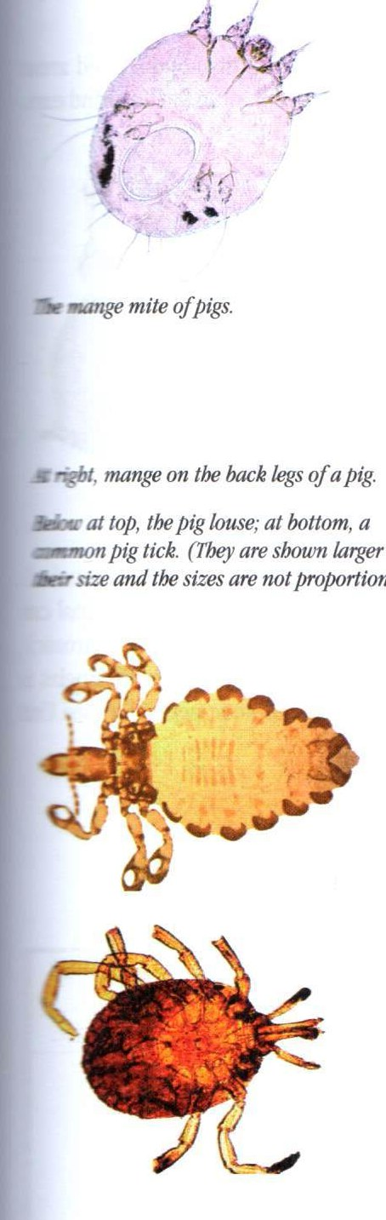
Mange
Pigs can develop mange, which is caused by mites. It results in a thickening and crusting of the skin. The activity of the mites burrowing into the skin makes the pig scratch. The wounds caused by this scratching can become infected with germs. Mange usually starts around the head, ears, legs and tail, but it will spread over the body if not treated. Mange is controlled as follows:
- Spray or dip the animal or paint the infected area with a suitable insecticide such as malathion.
- Thoroughly clean out and wash down the pen and shelter.
- Spray the pen and shelter with a suitable insecticide such as malathion.
- Repeat the treatment of the animal and the pen and shelter after 2 weeks.

Lice and tick infections
- Pigs can also suffer from infections caused by:
- Lice, which are dark colured and can be seen on the animal’s body. The lice feed on the skin and irritate the pig. This skin irritation causes the pig to scratch, which may cause wounds that can become infected.
- To treat and prevent lice from spreading, clean the areas where the animals are kept and spray the pigs and their pens with an insecticide such as malathion or coumaphos.
After working with many pigs, wash your hands and clothing, thoroughly because humans can catch the mange infection.
- Ticks, which suck blood. Ticks are dangerous because they can spread other infections to pigs.
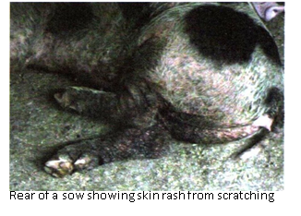
- To treat and prevent ticks from spreading, spray the infected animals with a suitable chemical such as malathion or remove the ticks by hand making sure the mouth parts of the tick are removed, or wet them with kerosene
- to kill them.
- Clean the pens thoroughly cleaned and spray the pens with an insecticide such as malathion. Fortunately, tick infections are quite rare with pigs.

Erysipelas (diamond skin disease)
Erysipelas is a bacterial infection. It produces reddish, diamond-shaped areas on the pig’s body or the animal may have a purplish colour to the head and ears. Pigs with erysipelas have a high temperature, do not feed, and squeal if touched. If the infection is serious and develops quickly (acute), the infected animal can die. In cases that develop slowly and last over a long period of time (chronic), the animal survives but suffers from swollen joints and lameness. Erysipelas is treated by injecting the infected animals with the antibiotic penicillin. Vaccinating pigs can prevent the disease.
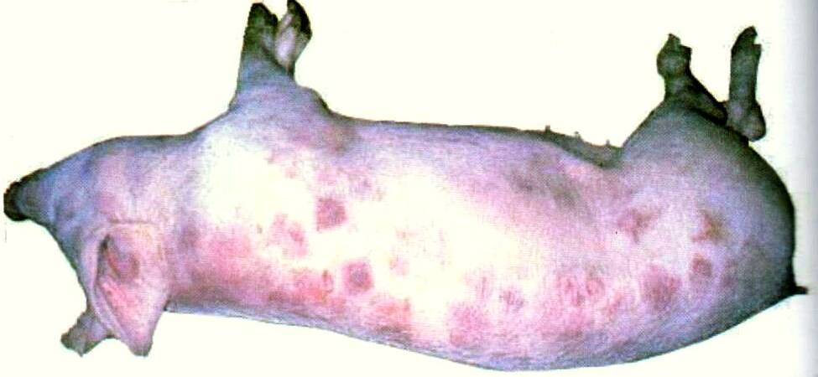

Some common diseases that should be updated in this training manual include:
- Foot rot  - Blood scours  - Salmonellosis  - Pneumonia | - Leptospirosis  - Glasser’s disease  - White scours  - Swine anthrax

What does ‘biosecurity’ mean?
Some basic first aid for piggeries:
Castrating knives
Cotton wool
Iodine, 95% Ethanol, Dettol,
Penicillin (if affordable)
A contact for someone you can trust for advice or assistance. (See page ##)

Biosecurity is about keeping healthy animals to make sure that animal meat is healthy for humans to eat – keep your customers safe!

The best way to keep your animals free of disease is to stop it from coming into your farm in the first place – stop diseases from entering!
It’s also important to keep sick animals away from healthy animals – stop diseases from spreading!
Pay attention to your animals so you know when there is a problem – find out as soon as possible!
Get the best advice available for animals that you think may be sick – treat diseases quickly!
Sometimes badly affected animals will need to be killed and buried or burned. This makes sure that a bad disease will not spread any further and come back to your animals too – keeping your own and every other farmer secure!

Biosecurity is everyone’s business.

Parasites and other common diseases of pigs
- Papua New Guinea has low cases of very bad diseases but internal (worms) and external (lice and mites) parasites are very common problems.
- The National Agricultural Quarantine and Inspection Authority (NAQIA) and the Royal Society for the Prevention of Cruelty to Animals (RSPCA) are the only organisations that provide veterinary services in PNG.
- Farmset Limited supplies most of the important veterinary medicines for livestock.
- A para-veterinary service has been talked about by government agencies, but there is still no practical servicing to rural areas and even to farms closer to towns.

Thinking together
- What are some cases of disease that you have seen? And how was the disease treated?
- Do farmers use local knowledge to treat their pigs or other animals?

Working together
- Talk about some practical ways that assistance or advice can be made available to local farmers.

Session 4: Reproduction and growth
This session deals with the reproduction cycle of the pig, and the care of the mother pig and piglets.

Learning goals

Farmers will
- Explain when a female pig is ready to breed;
- Explain how often a sow comes into heat;
- Describe the signs of heat in a sow;
- Explain how to make a sow come into heat
- Explain how to care for a pregnant sow;
- Explain the signs that indicate a sow is about to farrow (give birth);
- Describe normal farrowing;
- Describe farrowing problems and how to deal with these problems;
- Describe some important things you should know about a sow’s mammary gland;
- Describe the signs that indicate piglets are feeding well; and
- Explain how to foster piglets and raise piglets by hand.

Heat (Oestrus)
The gilt (a young female pig that has not yet given birth) is ready to breed when she reaches puberty at about five months of age. At this stage, the pig will show signs of being in heat. Some slow –growing gilts and underfed animals will take longer to reach puberty. The sow will come into heat every three weeks throughout the year if she is not mated.

A few points about breeding
It is very useful to know when pigs are ready to breed and which pigs should be used for breeding. The following points are good to keep in mind:
- Most types of pig come into heat for the first time (reach puberty) at about 5 months of age. There are some types of pig, for example the Chinese pig, that reach puberty at about 3 months of age if they have enough good food and water.
- A pig should not be used for breeding when she comes into heat for the first time. It is better to allow her to grow for another month. A six-month old sow has a better chance of carrying and suckling a litter of young.
- Only sows with 14 teats should be used for breeding. The sow with 14 teats will be able to feed a large litter.
- A sow that is not pregnant comes into heat every 21 days, provided she has enough food and water.
- A sow that is in good condition should come into heat within 5-10 days after her piglets have been weaned. She should be mated at this time.
- A sow will be in heat for 8-36 hours.

Signs of a pig in heat
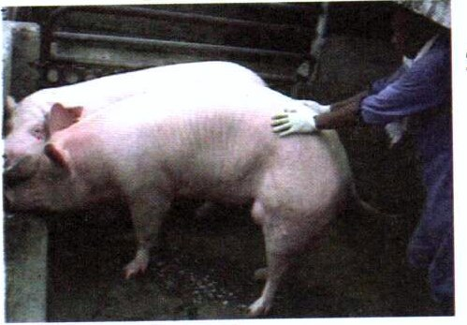
- A female pig coming into heat is restless and may not eat.
- The vulva becomes pink and swollen.
- When the sow in heat is pressed hard with the hands on either side of her back she will stand still (back pressure test). This indicates she is ready to accept a male.

How to bring a sow into heat
Healthy, well fed sows can be brought into heat. Bringing sows into heat at a convenient time enables the farmer to control breeding. There are two ways to cause a sow to come into heat:
- Put a sow that is in heat with sows that are not in heat. Some of the sows will come into heat.
- Put sows in a pen next to a boar so they can see and smell him. The sows will come into heat, especially if the boar is old and smelly. This is the best method of bringing a sow into heat.

Pregnancy and farrowing (Giving birth)
- A well-fed sow will produce a litter of at least 10 piglets from each pregnancy, and can have more than 2 litters per year.

Care of the pregnant sow
If the sow shows no signs of being in heat 3 weeks after mating, she is pregnant. The pregnancy will last about 3 months 3 weeks and 3 days. During the pregnancy, care for the sow in the following way:
- Give the sow plenty of high-nutrient food and plenty of water every day. She will need more food towards the end of the pregnancy. Foods high in nutrients include breadfruit, cassava or grain, as well as green vegetables and fruits like pawpaw or bananas.
- Give the sow access to clean soil, or give her grass with roots from land where no pigs have been kept. This will allow her to get the minerals she needs.
- Give the sow plenty of clean bedding when birth is close.

Signs that the pig is ready to farrow (give birth)
- The sow becomes restless and starts to make a nest in the 24 hours before she gives birth.
- The teat will produce milk when gently squeezed.
- Blood-stained fluid may be passed from the vagina 1-2 hours before birth begins. If small greenish pellets appear, the first piglet will be born within an hour.
- Gently rub the udder to make the sow relax and lie on her side, which is the best position for giving birth.

Normal farrowing
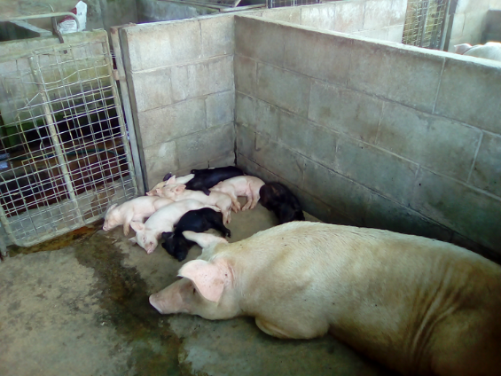
Farrowing is a natural process, and the sow will usually give birth without help. Once the first piglet is born, the other piglets and the afterbirth will quickly follow.
- Farrowing should be completed within 2-3 hours.
- The navel cord will break (you do not need to cut it), and the piglet will immediately search for a teat and drink milk (suckle).
- If the navel cord bleeds, tie it tightly with clean string or cord.
- You can wipe the navel of each newly born piglet with an antiseptic such as iodine to help protect against infection.

When and how to help in farrowing
Sometimes a sow will have a problem farrowing. There is a problem if:
- The sow shows all the signs that she is ready to farrowing, but she has not produced a piglet and is pawing with a hind leg; or
- 45 minutes have passed since the first piglet appeared, and there is no sign of the second piglet.
If the sow appears to be having trouble farrowing, you will need to help her:
- You may wish to restrain the sow when helping her to farrow. You can do this by tying her back legs together.
- Remove your watch and jewellery. Germs under rings and watches can cause infections.
- Make sure your fingernails are cut short and are thoroughly clean. Long nails can hurt the animal, and germs under your fingernails can cause infections;
- Wash your hands and arms with warm water and soap, and thoroughly wash the vulva and surrounding area with soap and water.
- Soap your hands well, and put your hand into the vagina and feel for the piglet or anything causing a blockage. Try to remove the blockage.
- When the piglet comes out, clear its mouth and nose of mucus. If it is not breathing, slap it to encourage it to breathe. Gently rub the piglet dry and put its mouth on a teat.

Care of the sow and piglet
A healthy, well fed sow will be able to rear at least 20 piglets each year. If a sow has too many piglets to feed or if a sow dies, the young can be fostered or raised by hand.

A few points about a sow’s udder
The following are a few things to know about a sow’s udder:
- A sow should have at least 14 teats. The teats should be long and thin enough for the piglet to grasp.
- As a sow gets older and has more litters, the teats can become large, making it difficult for the piglet to suckle. When this happens, the sow is no longer fit for breeding.
- A sow can develop mastitis as a result of damage to the teats caused by piglet’s needle teeth. Clipping the needle teeth of the piglet prevents cuts to the teats.
- Sometimes the back teats in an old sow do not produce much milk. An old sow may be unable to feed all her young. When this happens, the sow is no longer fit for breeding.

Fostering piglets
Sometimes it is necessary to foster piglets. A sow might die, or she might not produce enough milk for her litter. If this happens the piglets can be fostered to another sow. The orphans should be mixed in with the new sow’s own litter so she will accept them. The foster mother will not be able to feed all the piglets of another litter as well as her own litter. The orphans have to be placed with different foster mothers.

Hand rearing piglets
There are times when no foster mother is available. In such a case, the litter can be raised by hand feeding;
- All piglets must take sows milk (colostrum) from the mother within 1 hour of being born. If the sow is unable to provide milk to her piglets then cow’s milk is the best substitute.
- After 3-4 days, the piglets can be given cow’s milk using feeding bottles and teats. If there is no fresh cow’s milk available, you can feed the piglets milk made from milk powder.
- Thoroughly clean the feeding bottles and teats between each feeding.
- Regular feeds must be given at intervals of 1-2 hours.
- Use a clean, dry box containing clean bedding for the newborn piglets, and keep it in a warm place.

How to tell if the piglet is feeding well
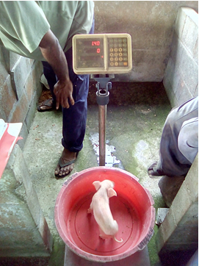
Watching for signs of poor growth is an important part of caring for young pigs. Not all piglets in the litter grow at the same rate, for the following reasons:
- Each piglet suckles from its own teat, feeding every hour. The first-born and stronger piglets use the teats nearest the sow’s head, which produce the most milk.
- Some piglets are born smaller than the others (runts). The runts will be smaller than other piglets in their litter throughout their growth.
A two-day old piglet being weighed in a large dish.
- Piglets fight for food. The smaller ones will grow at a slower rate and might die.
You can expect to see differences in weight gain and growth between piglets in any litter, but if none of the piglets grow well there is a problem. If there are no obvious signs of disease, you should suspect poor milk production by the mother. This is often the case with old sows.
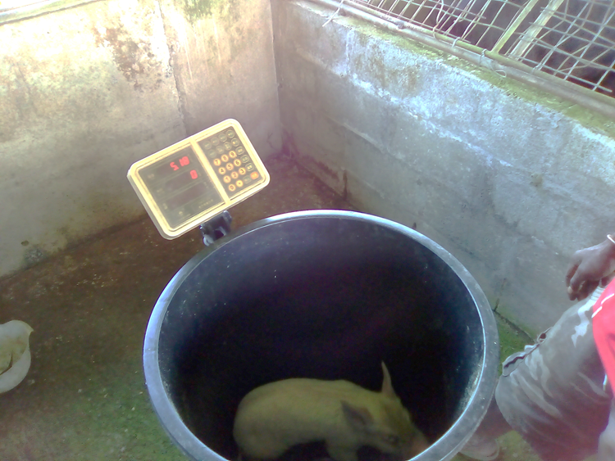
The two pictures show the same piglet at farrowing and two weeks later.
Piglet grew from 1.4 kilograms to 5.2 kilograms in 14 days. That means a growth rate of about 270 grams per day.
This is a very good performance for crossbred pigs (Labu Station).
Village pigs may not grow as well but other crossbred pigs (Rumion Piggery) may grow even faster!
The same piglet being weighed in a large bucket at 16 days old.

Weaning
Piglets show an interest in solid food when they are 1-2 weeks old. Piglets in the field will naturally start to eat solid food, but it must be offered to piglets that are housed. At first, they can be offered a handful of coconut meal, sugar or powdered milk. To avoid digestive problems, give new food gradually. Piglets will take milk from the mother until they are about 6-8 weeks old. They will gradually take less milk and eat more solid food until they are weaned.

Growing and finishing pigs
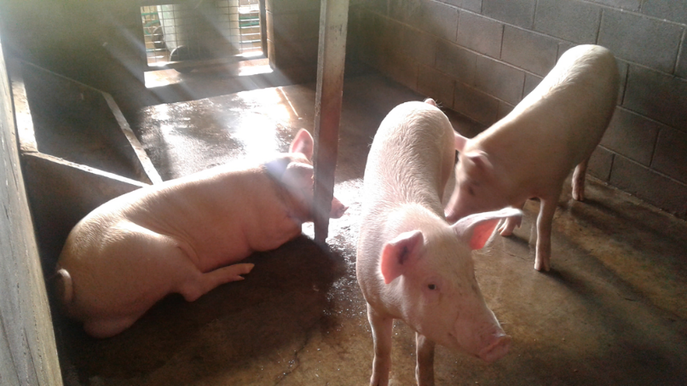
Growing pigs need a good food regularly or should be allowed to eat to satisfaction if there is enough feed. They will quickly lose their form when they are not fed well and this makes them fight more, can weaken their bodies and allow minor infections or diseases to affect them more. If this happens it will be more difficult to get them to regain their good form and take a lot more effort, and cost more, to help them recover.
Finishing pigs are bigger animals and don’t need as much of the really good feed as growing pigs. They can be maintained on the less nutritious feeds when there is a bad season.
It is best to separate growers and finishers according to their size to prevent smaller pigs from being chased off the feed.
A healthy and well growing animal will be active and playful, bright eyed and the skin will be in good condition.
If the pigs look tired and the skin is dusty, and if there is pekpek running down the backside, then it is likely that the growing animal is not doing so well.
Finisher pigs may be less active than growing pigs but they should respond well when approached for feeding. In most pig breeds the ears stand up or move about when they are active.
Also watch the standing form of the bigger pigs. If the legs are wobbly and the pig has trouble walking that may be a sign that the pig is unwell or has some injury.
An injured pig may stop eating altogether and may be chased away from feed. It may be necessary to separate sick or injured animal from other pigs so that they can be able to recover. This also prevents spread of the illness to other pigs in the herd.

Reproduction and growth
- Making sure that the sow is producing well is critical for successful pig farming.
- Making sure the piglet is well looked after ensures that a farmer will be rewarded for hard work with more pigs.
- Larger animals may be sacrificed or their feeding reduced if there is a need to maintain stock during bad seasons.

Thinking together
- What are some of the problems with breeding animals?
- What are some of the main problems with piglets?
- What are some of the main problems with growing animals

Working together
- Talk about some practical improvements which may be possible to help maintain local pig health and growth from sow to finisher pig.

A list of contacts for advice
Organisation | Personnel | Phone/mobile | Email
NAQIA (Lae)
NAQIA (POM)
RSPCA (Lae)
RSPCA (POM)
PDAL (Lae)
PDAL (Madang)
PDAL (E. Sepik)
PDAL (W. Sepik)
NARI (Lae)

